Initial Project Proposal

Year: 2021 Semester: Fall Project Name: Sink or Be Sunk

Creation Date: June 1, 2021­ Last Modified: June 1, 2021

Team Members (#1 is Team Leader):

Member 1: Mitchell Arndt Email: arndt20@purdue.edu

Member 2: Garret Brillhart Email: gbrillha@purdue.edu

Member 3: Joe Mislansky Email: jmislans@purdue.edu

Member 4: Molly Arito Email: marito@purdue.edu

1.0 Description of Problem:

The COVID-19 pandemic has invigorated the push for socially distanced activities. While Battleship is one of the few permissibly distanced board games, the electronic and more modernized versions have their faults. The new physical versions either share one board or have minimal electronic functioning aside from blinking lights and buttons for coordinate calling. On top of this, in the most modernized versions, such as cell phones apps, the essence of the game is lost; tactile involvement is limited to tapping squares on a screen, the coordinate calling system has been eliminated, and the famous “hit”, “miss”, and “You’ve sunk my battleship!” are foreign to present-day players. As a result, these contemporary spinoffs risk a loss of player engagement. In order to revive Battleship’s notoriety, our team will construct a version tailored to today’s society that will further optimize its socially distanced aspect and energize gameplay with new electronic features while reinforcing its origins.

2.0 Proposed Solution:

To create the most engaging and socially distanced version of Battleship, our team has conceptualized a variety of ways to enhance the game experience while keeping its integrity. The first obstacle is to maintain social distancing. Our team plans to implement a connection between two boards via WiFi from the ESP32 and web sockets, allowing for optimal and adjustable distancing. We will use a server to host the code for the game play logic, which validates legal plays on both boards. To reinvigorate gameplay, our team will engage with the players through touch, sight, and sound. Players will firmly place, or lock-in, their boats on the boards in the beginning of the game and place pegs into their opponent’s board to simulate missiles or torpedoes (depending on gameplay selection). For each “attack”, LEDs corresponding to hits or misses will flash on both players’ boards, creating a stronger visual appeal. When a boat is decimated, each setup will vibrate and audibly announce which boat has sunk, which will not only keep players interested but reproduce the incentive to win. Finally, to put a spin on the traditional playing style, we will create a variety of game modes. These different modes will allow players to play casually or competitively, quickly or for longevity. The various play options will further player interest simply by allowing the players to play towards an objective of their choice.

3.0 ECE477 Course Requirements Satisfaction

This project will require a microcontroller to detect user interactions in the form of placing ships and inputting a new move. Additionally, the microcontroller will facilitate the audio and visual cues such as explosion sound effects and hit/miss indicating LEDs. There will also be battery monitoring and charge indication. Finally, an integral functionality for the microcontroller will be to handle the wireless connectivity. This will be done by serially communicating with the ESP32 via a USART connection. The microcontroller will be sending information on the player inputs/interactions to the web server that handles the logistics of the gameplay.

3.1 Expected Microcontroller Responsibilities

Audio/Sound Effects

* DAC

Visuals

* LED array for hit/miss indication
  + driven by GPIO

User Input

* photo resistor “button” matrix for ship detection
  + GPIO inputs
* push button matrix for user move inputs
  + GPIO inputs

Battery Monitoring

* ADC input

Battery Low Indication

* GPIO output

Wireless Communication (to WebSocket Server)

* ESP32 via USART

Game Vibration

* Game console rumble motor
  + GPIO output

3.2 Expected Printed Circuit Responsibilities

* Main Microcontroller (STM32 F0)
* Speaker
* LED array
* Push button matrix
* Photo resistor matrix
* Battery holder
* Wireless communication module (ESP32)
* Rumble Motor/s

4.0 Market Analysis:

The target market for this product will be the board game industry. Technological advances have leaked down to every aspect of our lives including the simplest of board games. This industry is projected to have a compound annual growth rate (CAGR) of 13% from 2020-2026. Additionally, as Battleship falls into the tabletop games category, it is important to consider this subsection of the market specifically. The tabletop games category is projected slightly above the average with a CAGR of 14% in that same period. These statistics show that there is a growing market for our product. Additionally, it was found that Strategy and War games are the most popular topic for board games which means that our idea will fit right into this.

Covid 19 has had far reaching consequences and has impacted virtually every product industry. Covid has revived interest in the board game market due to many families spending extended time isolated inside of their houses. We can use this trend and couple it with another overarching trend of modern life. There is a push to digitize games and provide supporting applications to improve customer engagement in these games. With the combination of these two market forces, we can capture the restless audience with an exciting new way to play classic board games. Following the eventual end of Covid times, these trends are expected to continue. This means that little will change in terms of the demand of these products. In other words, customers will continue to be interested in unique board game experiences into the foreseeable future.

5.0 Competitive Analysis:

5.1 Preliminary Patent Analysis:

Below are patents relevant to “Sink or be Sunk” to both ensure no patents are infringed upon as well as expose relevant intellectual property rights.

**5.1.1 Patent #1: Electronic gaming platform having shared and private screens**

### Abstract [3]

An electronic gaming system configured for executing an electronic game on a plurality of terminals, each terminal having a corresponding monitor the electronic game having a public portion and a private portion, wherein when the electronic gaming system is executed by the terminals, it causes the terminals to display the public portion of the game on one of the terminal's monitor; display a private portion of the game to on the other terminals monitors; enable wireless communication between the terminals; and manage flow of the game according to game rules and the wireless communication.

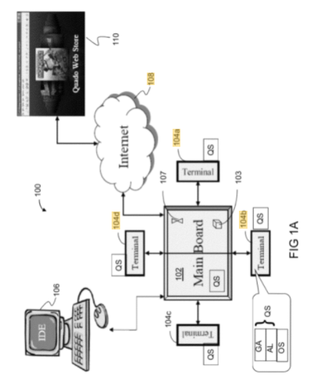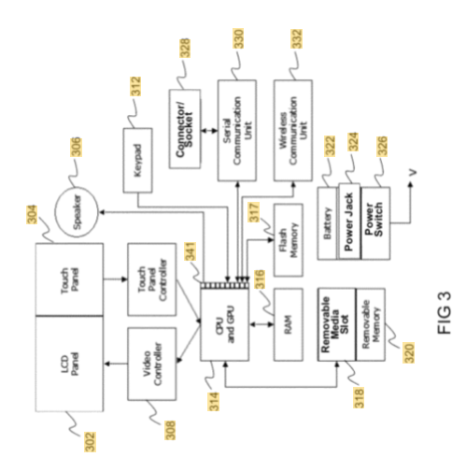

# **5.1.2 Patent #2: Closable-type game board box for strategic word pattern engagement**

Abstract [4]

My child educational board game, “Word Battle”, requires players to approach word learning, sequencing, and construction from a naval/military strategist point of view in that instead of targeting objectives in a mere hit-or-miss situation, where the goal in and of itself is to reach and eliminate occupied coordinates, he/she must locate and actually identify the quality of opponents' pieces (these being letters) before the other competitors capture or eliminate out of play all his/her own word patterns.

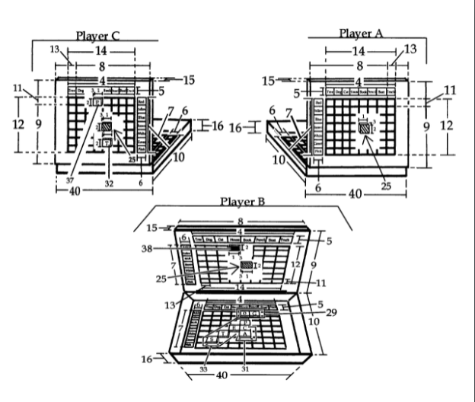

**5.1.3 Patent #3: Inclined surface feature for game assembly**

Abstract [5]

A game device that uses an inclined playing surface to achieve the goal of making the game more convenient by allowing the player easier accessibility to game pieces. The game assembly includes a base, an upright module and a pair of support assemblies. The inclined playing surface is achieved through combination of a locking hinge and an interlocking set of bars. The locking hinge is achieved through the connection of a set of plastic fasteners on the pair of support assemblies to a set of notches on the base. The locking hinge allows the support assemblies to be able to pivot upwards towards the upright assembly. The interlocking set of bars is achieved through the even spacing of bars along the bottom edge of the base and the edge of the pair of support assemblies. An ergonomic design is achieved for player use of the game device with the base and upright assembly supported at the base, with the two gaming surface assemblies connected to the base such that when the device is on a supporting surface, the game surface assemblies extend angularly upwardly from the supporting surface to the base. The base may also include player interface electronic control panels.

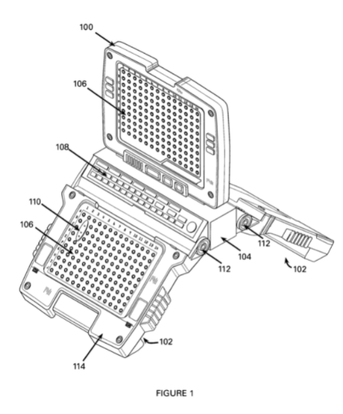

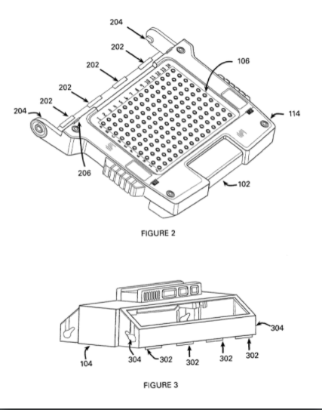

**5.1.4 Patent #4: Intelligent chessboard based on RFID technology and chess moving sensing method thereof**

Abstract [6]

The invention discloses an intelligent chessboard based on RFID technology and a chess moving sensing method thereof, wherein the intelligent chessboard comprises a chessboard body, a chessboard panel is arranged at the upper part of the chessboard body, a photoresistor is arranged on the chessboard panel, a base body is arranged at the lower part of the chessboard body, and a two-dimensional linear module is arranged on the base body; the photosensitive resistor is used for detecting whether chessmen exist at the positions of the falling chessmen or not; the two-dimensional linear module comprises a first motion module and a second motion module, the first motion module drives the second motion module to move along the X direction, and the second motion module drives the RFID sensor to move along the Y direction; the RFID sensor is used for reading RFID labels on the chess pieces; the controller is respectively connected with the two-dimensional linear module, the RFID sensor and the photosensitive resistor. The intelligent chessboard can realize the sensing of the whole chessboard falling information only by adopting the RFID technology, and realizes the auxiliary sensing of the falling position by the photosensitive resistor, thereby improving the sensing efficiency.

## CN110665211A

5.2 Commercial Product Analysis:

5.2.1 Electronic Battleship Game:

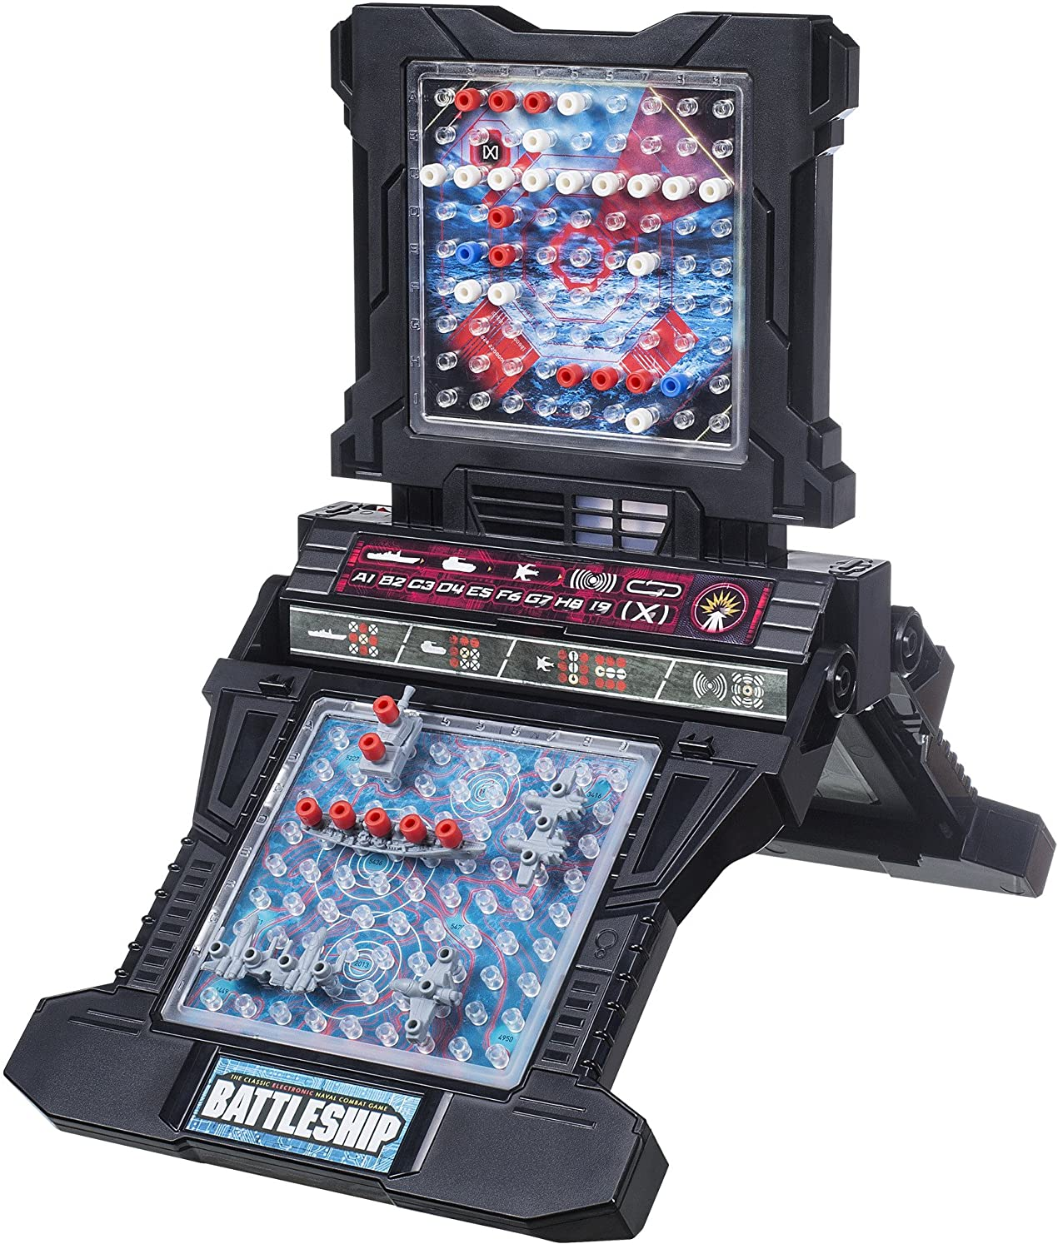

Technical Description:

This design uses a button array to indicate a player’s move and ship positioning. Players input their ships coordinated into the game through an arduous process of entering then confirming each ship location. There is a build in speaker that will generate sound effects for events in the game. There is one central red LED that will flash for any hit on the board. These hits are detected by the onboard microcontroller.

Pros:

* Compact design due to modest electronic integrations
* Great aesthetic quality
* Tangible ship and peg pieces add nostalgic touch

Cons:

* Only small differences from the non-electronic battleship experience
* Requires two players to play in same physical space
* Ship pieces have no real connection to the electronic tracking of the game

5.2.2 GamePigeon: Sea Battle

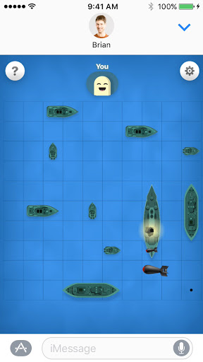

Technical Description:

GamePigeon is an add-on designed for IOS devices that provides a library of 2+ player games, one of which is a spin-off of the classic Battleship. In their version, “Sea Battle”, the users can arrange boats on either an 8x8, 9x9, or 10x10 grid. On the beginning of each turn, the players watch whether their opponent has successfully hit or missed any of their ships. Then, a replica of their opponent’s grid (without the ships) is presented. The player will select a box on their opponent’s grid and confirm the selection with the “send” button. If a ship is hit, the player is allowed to select another box. Upon the first “miss”, the turn is automatically passed to their opponent via iMessage.

Pros:

* Reduced chance of cheating
* Computer determines rules – no room for interpretation
* Ability to change the grid size (and number of boats)
* Can play anywhere with internet access for iMessaging
* Vibrations/visuals make game more intriguing

Cons:

* Boats cannot be placed next to each other
* Sometimes messages are unable to send/load
* Completely on device – minimal tactile experience
* Loss of “Battleship culture” - (no calling out “B4”, “C8”, “Hit”, “Miss”, “You sunk my battleship!”)
* Currently only available for IOS to IOS devices

5.2.3 Torpedo Attack:

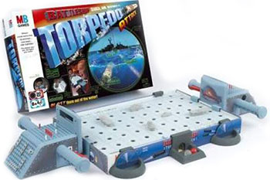

[How to play Battleship Torpedo Attack | Official Rules | UltraBoardGames](https://www.ultraboardgames.com/battleship/torpedo-attack.php)

Technical Description:

In this spinoff of Battleship, the objective is point-based rather than elimination-based. The players must first locate all coordinates of a ship before attempting to fire. Once an entire ship is identified, the player will fire place the respective type of ship on the ocean, between the two scopes. The player will then load a “torpedo” and use the periscope to search for the boat’s peg in the ocean. The number of points a player scores corresponds to the number of tries it takes for their torpedo to hit the boat peg; one attempt scores 200 points, two attempts score 150 points, 3 attempts score 100 points. After the third attempt, if the boat still has not been shot, it has “escaped” and the player does not receive any points. The first player to 1,000 points wins, or if all boats have been shot and neither player has reached 1,000 points, the higher score wins.

Pros:

* Very hands-on/interactive
* Higher stakes from point-based objective
* Periscopes make the gameplay feel more realistic

Cons:

* Players must share one board (cannot be socially distanced)
* Longer play time than battleship – could eventually becoming boring
* Scope mechanics are unreliable

5.3 Open-Source Project Analysis:

5.3.1 Open Source Project #1: Raspberry Pi Jumbo Battleship

This project in [7] is a super large, one player battleship game in which the player uses an old rotary phone to dial in the coordinates. The phone is used as a speaker as well to tell the player if they have hits or misses, as well as other sound effects. The LED board is also used to show hits and misses. This project online doesn’t provide a lot of examples as to how the hardware would work, except for the rotary phone connection. This could be used as a much more unique way for the user to use inputs, if we decided going against using the physical pegs as markers. The phone is wired to the GPIO pins of a raspberry pi. The software provided online for the rotary phone information parsing is licensed under the MIT License which means it can be used for any use. It is a python code designed to run on the pi to interpret the numbers dialed as well as output sound to the phone. This seems like a unique way to get input from the user; however, the design would need to be adapted to work with the STM.

5.3.2 Open Source Project #2: 3D Printed Battleship board

There are many designs online of different 3D printed boards, pieces, connections, etc., and they all inspire different ways of building the board. In terms of the board, you can have two different designs, but the one I kept coming back to was one that would fold closed like the traditional board game. From [8], I found a board design that would incorporate this as well as have the spots to store the pieces. This keeps with a compact design and provides for easy travel as all the pieces are contained. This design, as most from thingiverse.com are under the Creative Commons license which means the design can be used for free, however, it would require attribution. While this is one specific design, there are many online with different boat designs and sizes, which I think could be beneficial in deciding what designs and themes we want to use with the project. The disadvantage of using a previous designed 3D print file is that the design would have to be modified to fit out hardware. There is no room for the PCB board or any other electronics we would need, so we would have to compensate for that. This could be a good potential starting place with changes clearly being necessary.

5.3.3 Open Source Project #3:

This project in [9] is a way to take user input and send it to a webserver with an STM32 as well as take info from the webserver and push it back the user. In the GitHub code there is no mention of any sort of license, and on the main website there are direct download links and implications that the code can be used as the website provides tutorials on how to set it up. This specific project uses the webserver as an on/off for the LED, however, I believe it could be easily adapted to being a setup for the game. This could also be used as inspiration to setting up communication between two boards so users could play against each other. While this would be significantly more difficult, it would provide a seamless experience for the players.

5.3.4 Open Source Project #4: WebSockets WebServer

This project in [10] demonstrates how to use an ESP32 to create a web server. The ESP32 acts as an access point and hosts a webpage that users can connect to and view the webpage. This example uses an Arduino IDE which is something we’re not sure if we’re allowed to use. However, the application and design principles used in this project point us in the direction we want to go. This is a tutorial styled website and it doesn’t seem as if there are any licenses or use agreements to be able to apply the user’s code. The webserver works with HTML and performs GET requests but could easily be adapted to perform POST requests as well. Overall, I think this would be a super beneficial way to implement using a phone as the system to set the settings and connect two devices.

6.0 Sources Cited:

[1] A. A. & Intelligence, *Board Games Market Size to Reach Revenues of around 30 Billion by 2026 - Arizton*, 15-Dec-2020. [Online]. Available: https://www.prnewswire.com/news-releases/board-games-market-size-to-reach-revenues-of-around-30-billion-by-2026--arizton-301192937.html#:~:text=The%20global%20board%20games%20market,Highlights%20Offered%20in%20the%20Report%3A&text=a%20healthy%20growth%20CAGR%20around,incremental%20revenues%20during%202020%2D2026. [Accessed: 01-Jun-2021].

[2] ReportLinker, “The board games market by revenue is expected to grow at a CAGR of approx. 13% during the period 2021–2026,” *GlobeNewswire News Room*, 16-Dec-2020. [Online]. Available: https://www.globenewswire.com/news-release/2020/12/16/2145929/0/en/The-board-games-market-by-revenue-is-expected-to-grow-at-a-CAGR-of-approx-13-during-the-period-2021-2026.html. [Accessed: 01-Jun-2021].

[3] Haltovsky, M., Haltovsky, A., & Assa, S., “Electronic gaming platform having shared and private screens”, US Patent 8974282B2, March 10, 2015.

[4] Benedict, M., “Closable-type game board box for strategic word pattern engagement”, [US Patent 20080265506A1,](https://patents.google.com/patent/US20080265506A1/en?q=battleship+board+game&oq=battleship+board+game) February 23, 2010.

# [5] Foster, B., “Inclined surface feature for game assembly”, US Patent 763750B1, December 12, 2009.

# [6] [匡畅,](https://patents.google.com/?inventor=%E5%8C%A1%E7%95%85) 王思婷., “Intelligent chessboard based on RFID technology and chess moving sensing method thereof”, CN Patent 110665211A, January 10, 2020.

[7] TeCoEd. “Raspberry Pi Battleships.” Hackster. https://www.hackster.io/TeCoEd/raspberry-pi-battleships-9813f1 (accessed June 1, 2021).

[8] X3RPM. “Battleship (game).” Thingiverse. https://www.thingiverse.com/thing:472705 (accessed June 1, 2021).

[9] Controllers Tech. “Send and Receive data from the Webserver using STM32” Controllers Tech. https://controllerstech.com/send-and-receive-data-from-the-webserver-using-stm32/ (accessed June 1, 2021).

[10] Hymel, S. “How to Create a Web Server (with WebSockets) Using an ESP32 in Arduino.” Shawn Hymel.com. https://shawnhymel.com/1882/how-to-create-a-web-server-with-websockets-using-an-esp32-in-arduino/ (accessed June 1, 2021).

Appendix 1: Concept Sketch

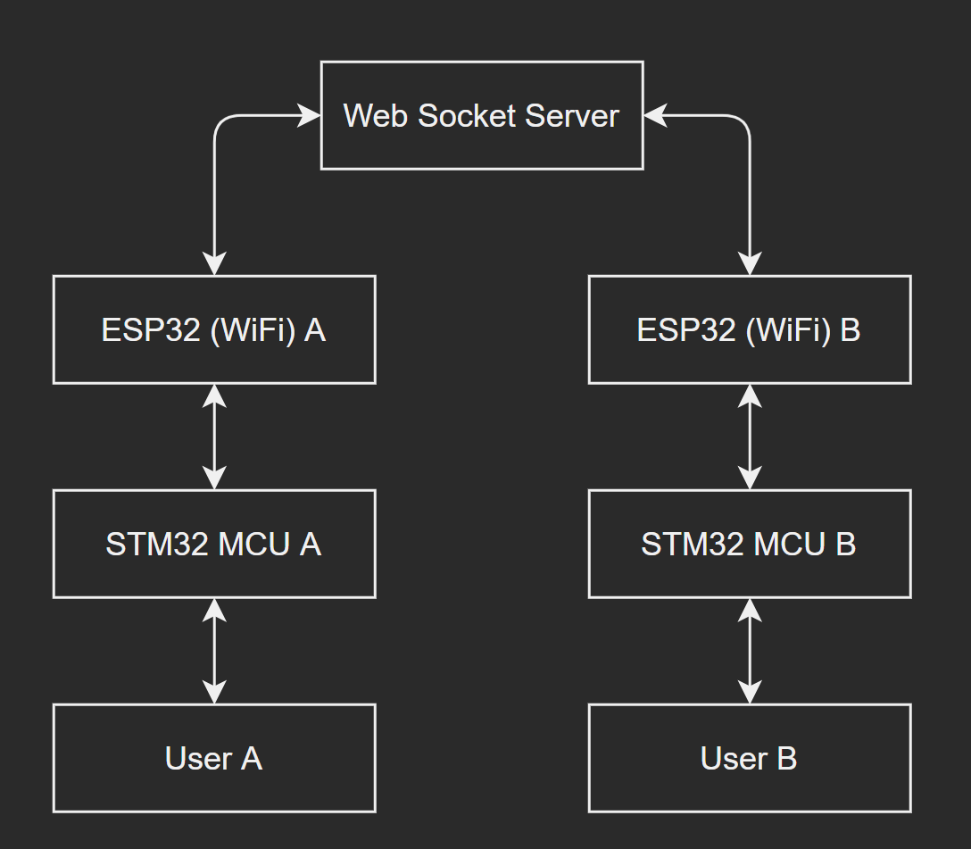

Gameplay dataflow overview

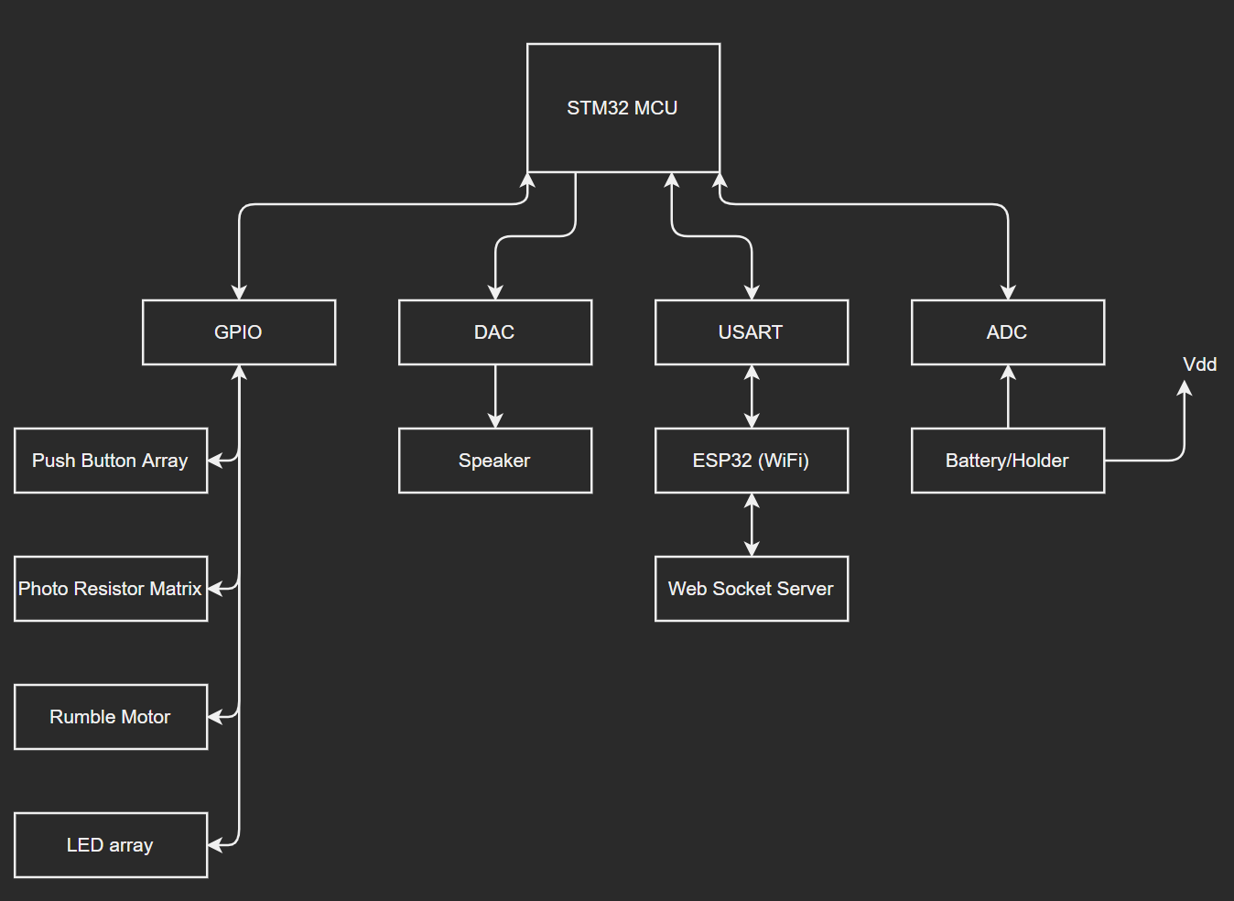

Microcontroller Subsystem Overview

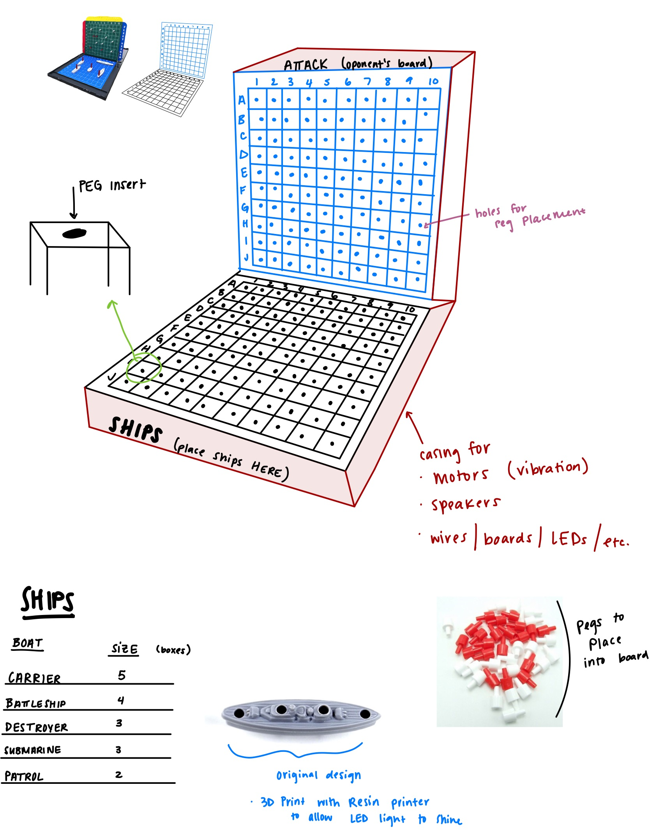

Game Board Layout and Pieces